# Nama : Fakhira Zahrany Nardin

# Nim : 2341760197

Kelas : 1G SIB Smstr Genap

Materi : Konsep Dasar Pemograman

**Mid Test 2023/2024**

Course : Algorithm and Data Structure Practicum

Kelas : SIB I

Day, Date : Tuesday, April 16th 2024

Time : 13.00 – 17.00

Lecturer : Rokhimatul Wakhidah, S.Pd., M.T.

**Exam Instructions**

1. Practical exams are honest and open

2. Please do it at your respective places.

3. The results of the work are in the form of a file in one folder containing the Java project and a PDF screen shot file resulting from compilation and coding

4. All work is uploaded to the LMS in one zip with just the NAME file naming format.

5. The same code structure is not permitted. 30% of the code structure is the same, repeating UTS.

**Exam questions**

1. Create a banking information system consisting of 2 diagram classes, namely Accounts and Transactions. In this information system you can

a. input data,

b. display data,

c. sort data by certain criteria, and

d. search for data

**Note: Views and class diagrams may be modified or added but may not be reduced.**

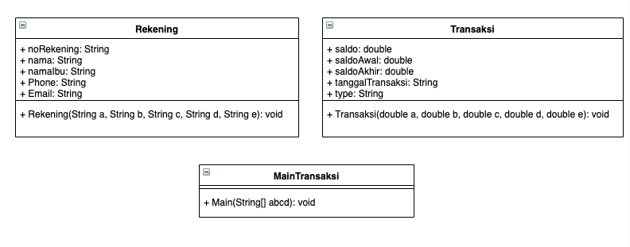

1. Input

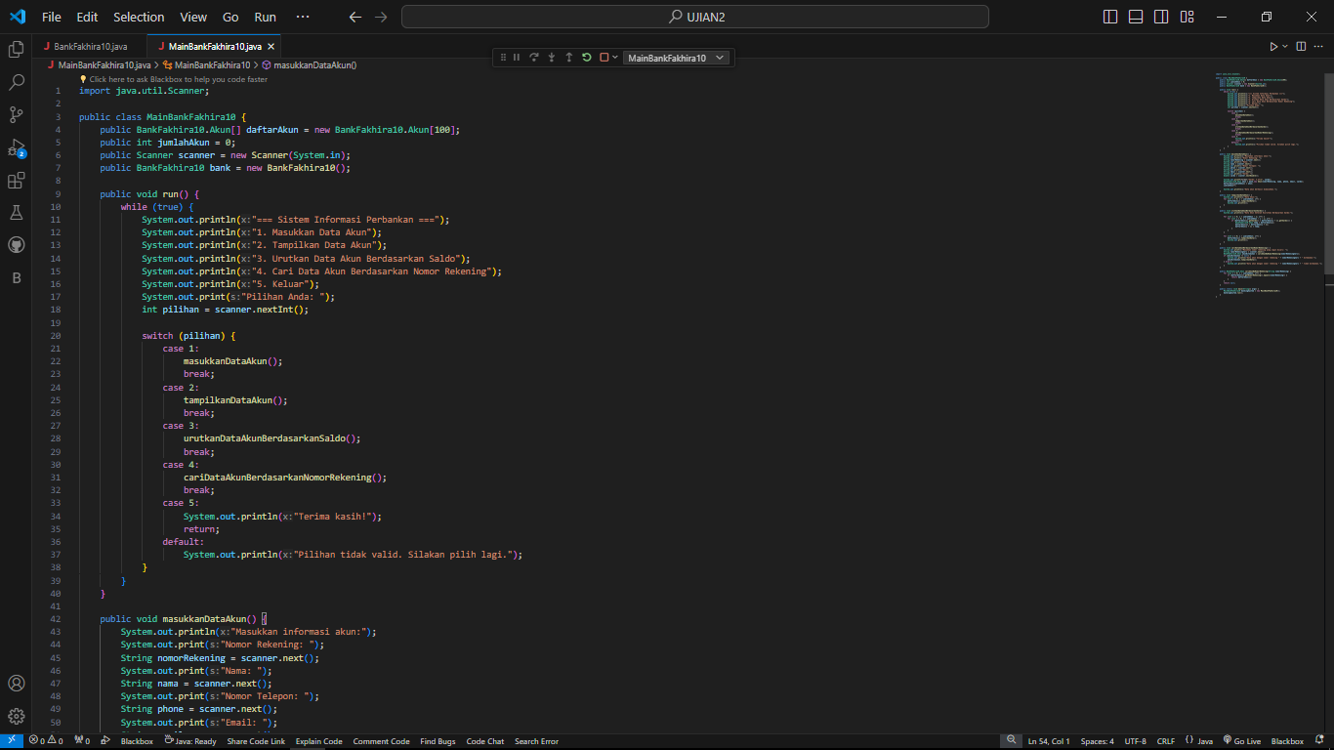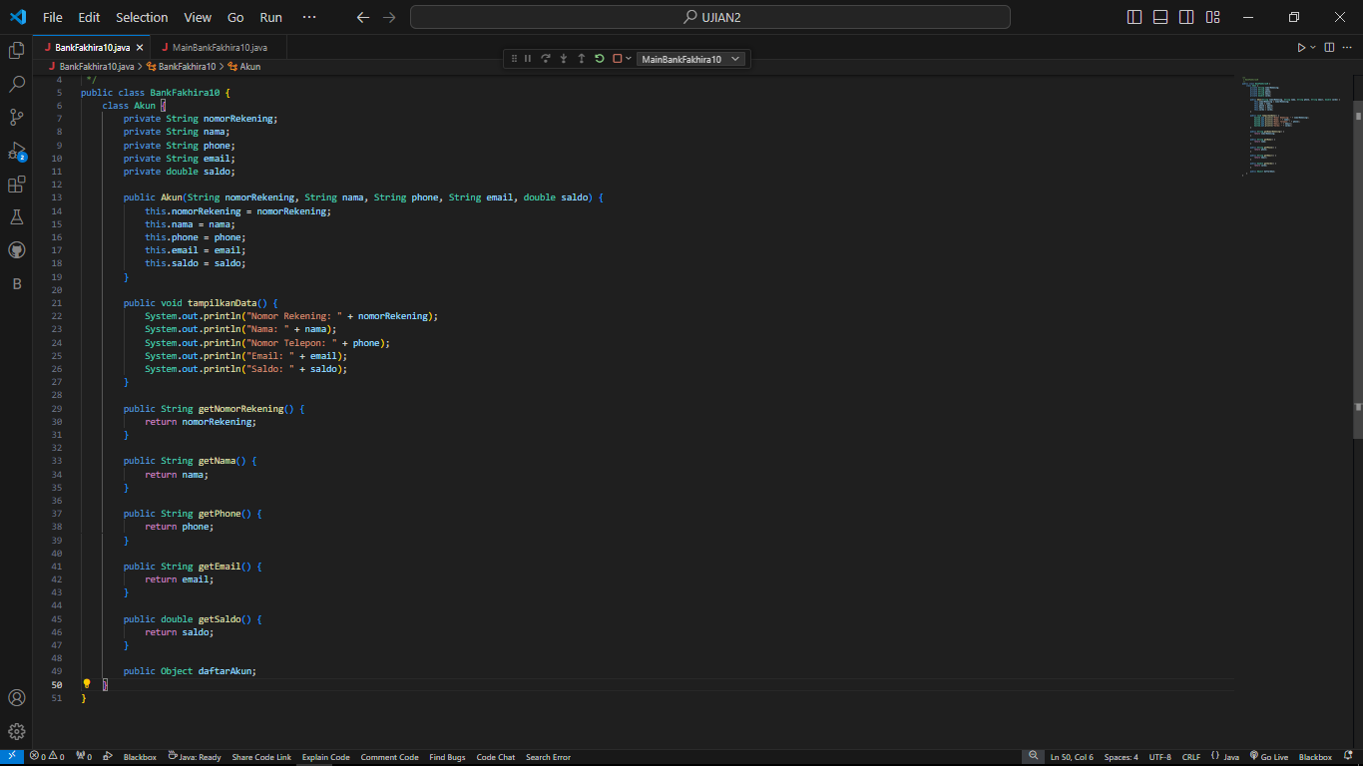

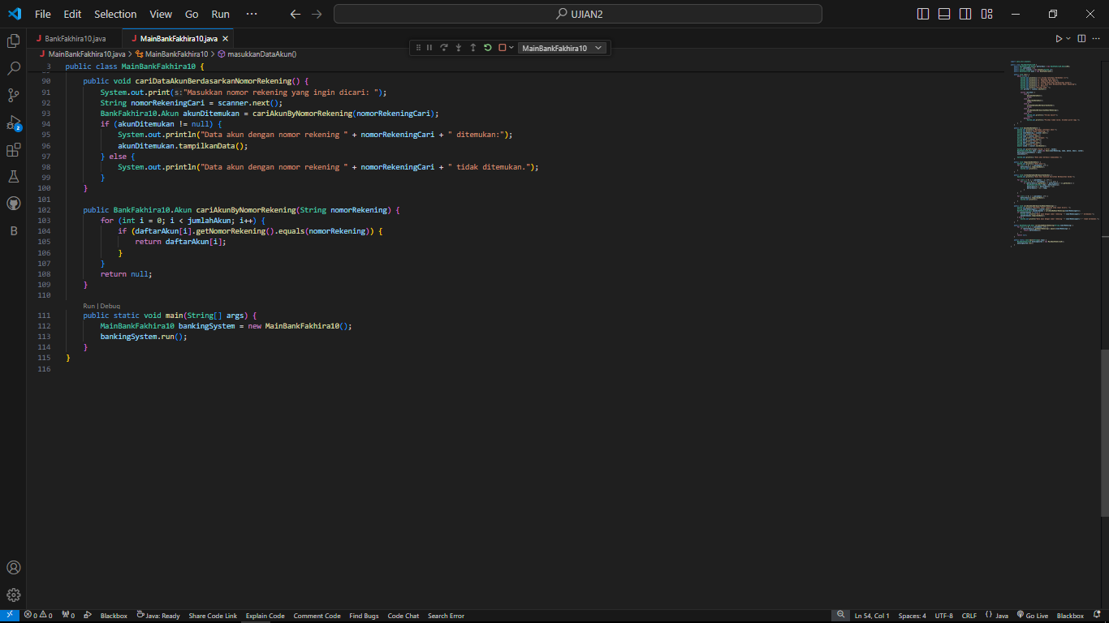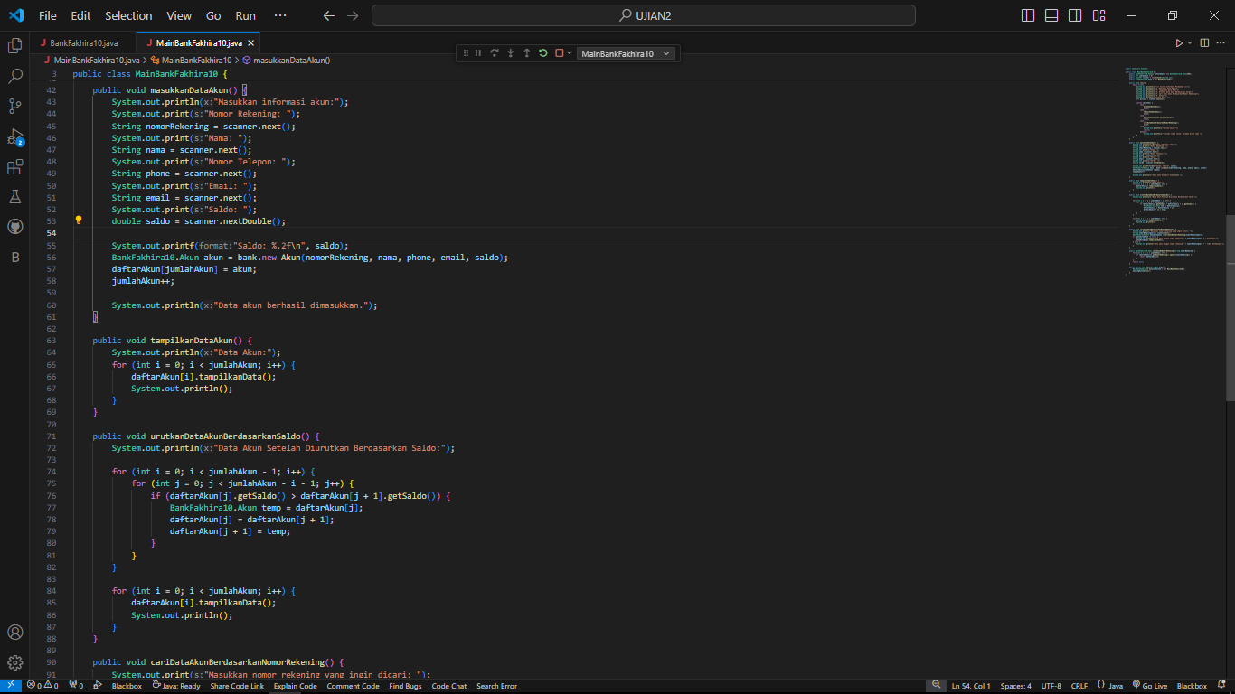

1. 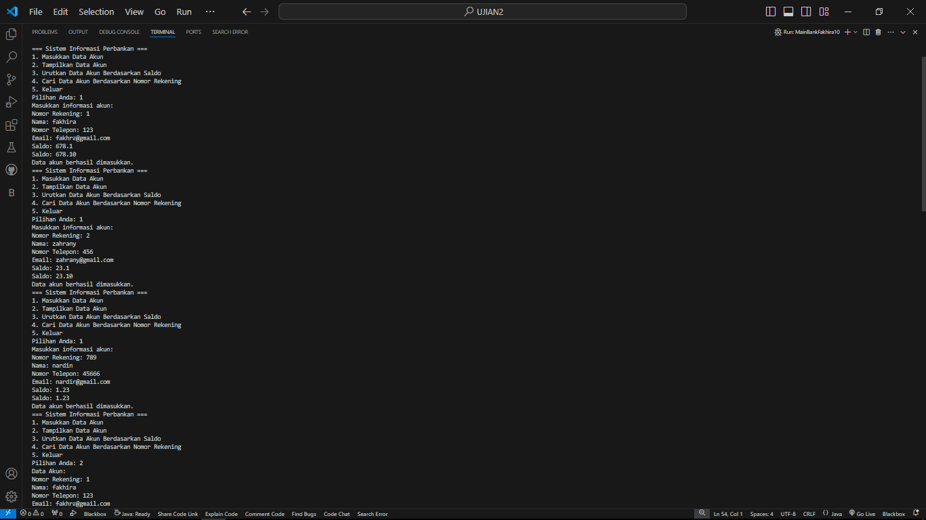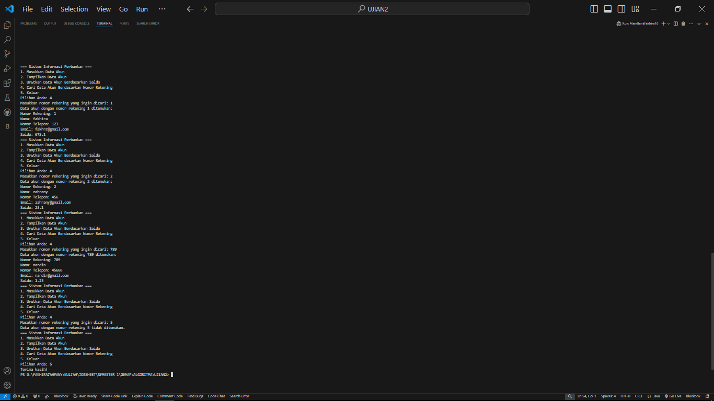Output

